Name: Soham Bhoir

Roll No.: 16010420117

Batch: A4

Running an application in a container, Docker and Docker Hub

Screenshots

Pulling the nginx image

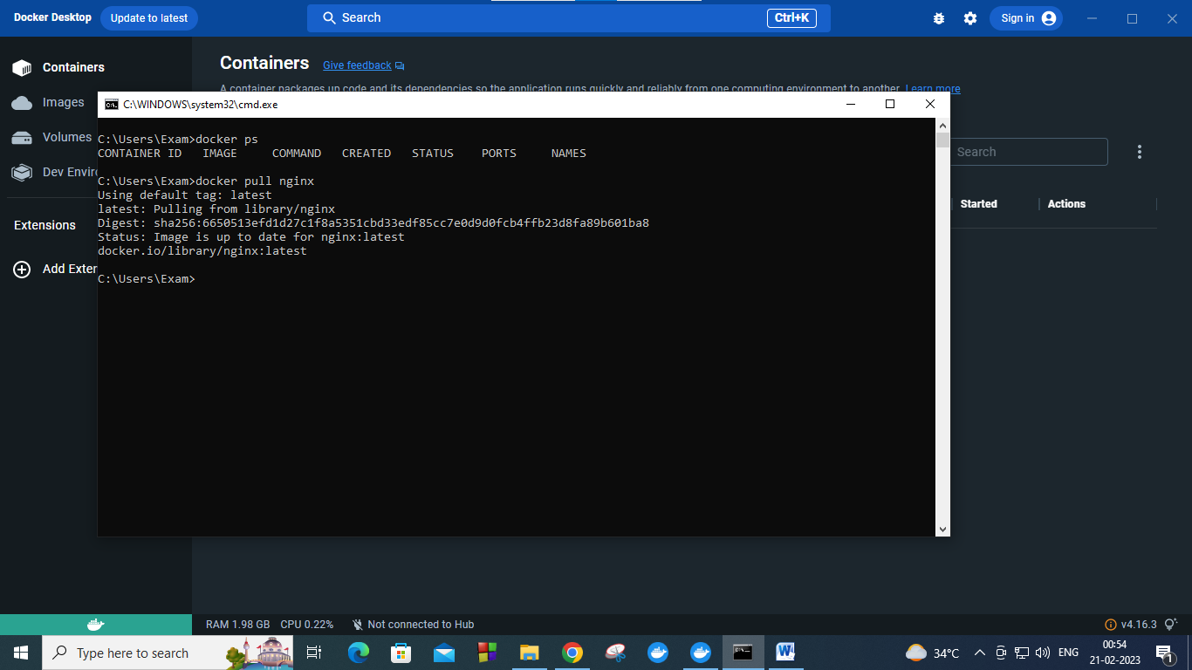

Running the nginx image

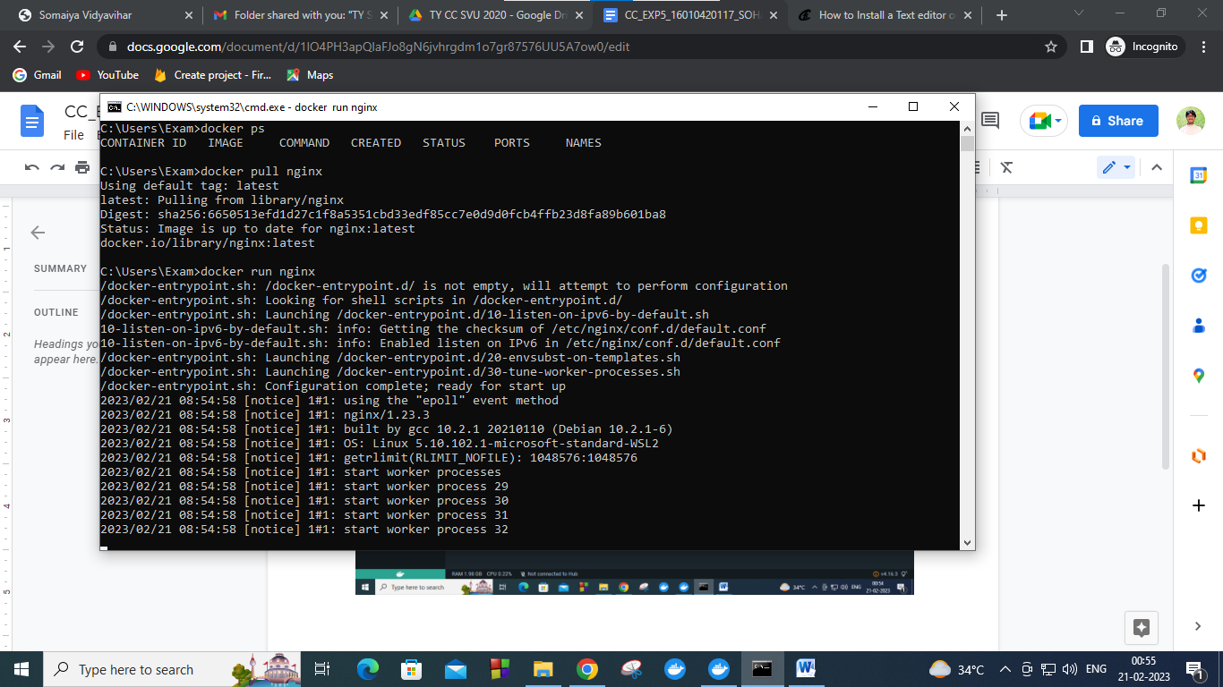

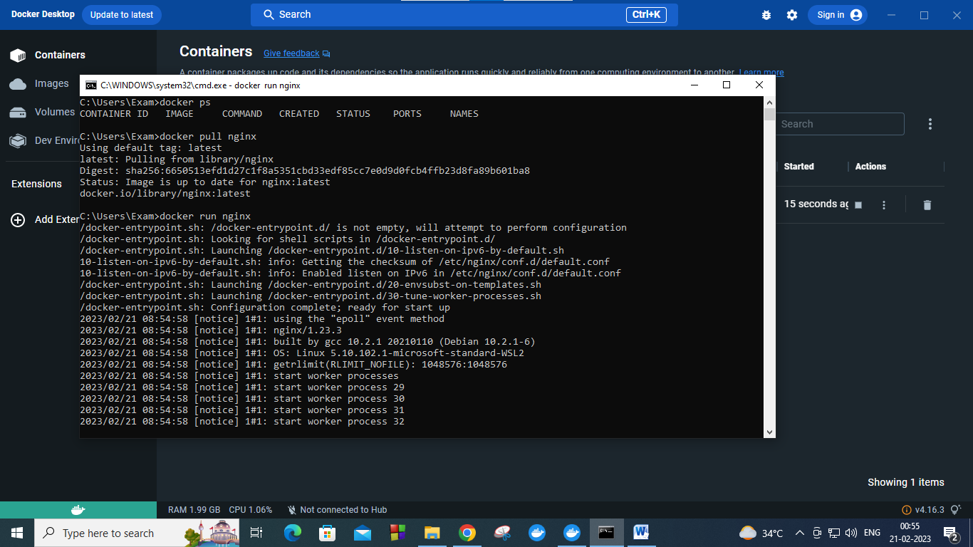

Giving port to expose

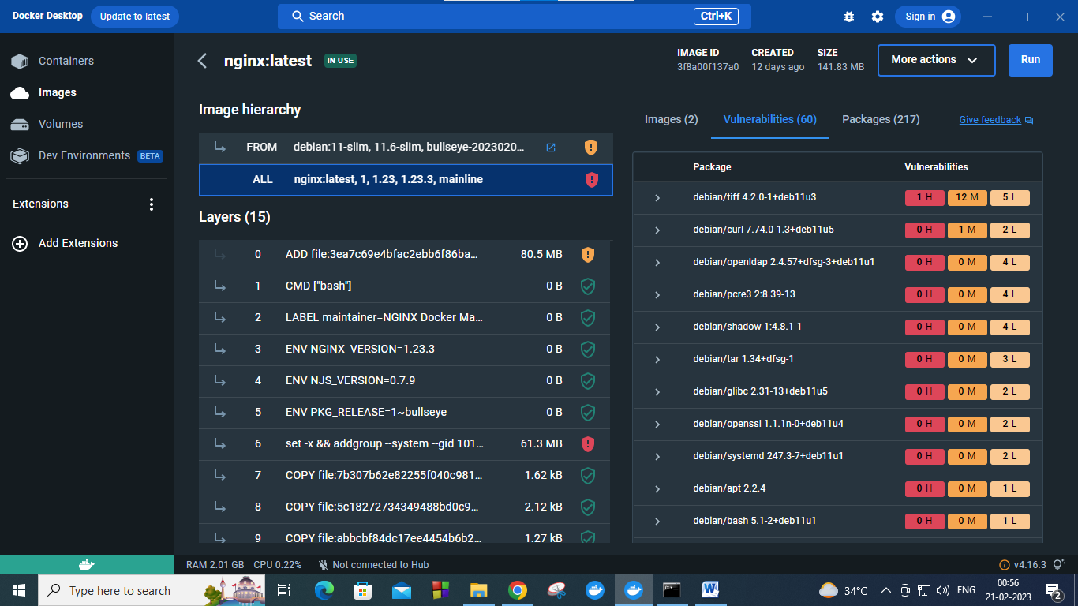

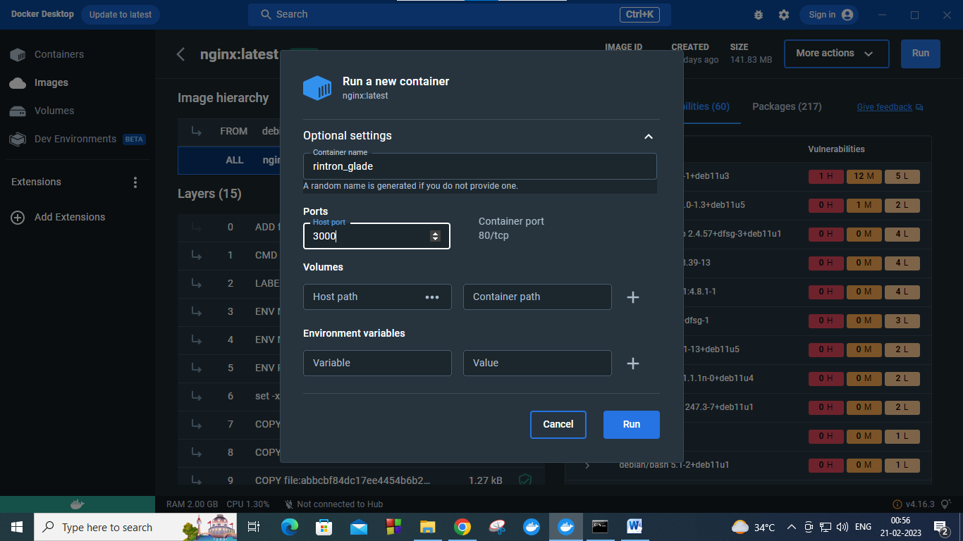

Output on exposed port 3000

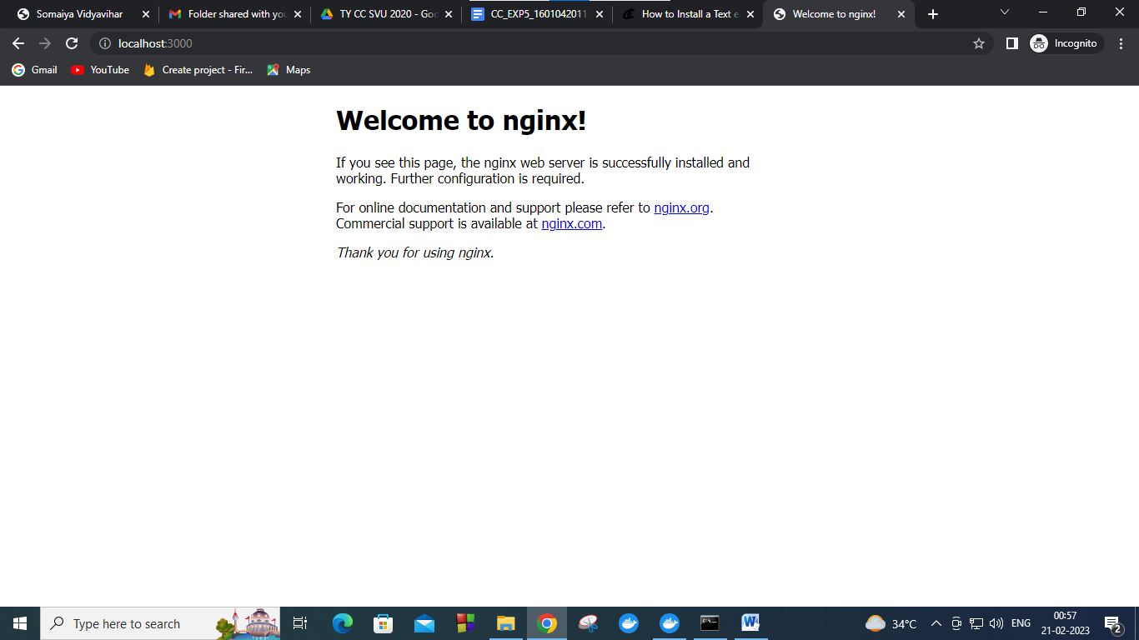

Locating the Index.html file via docker bash

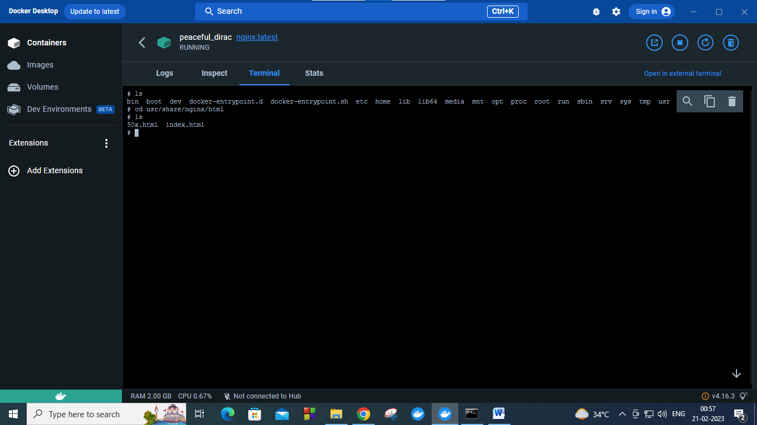

Updating the nginx base image ie the base image is debian

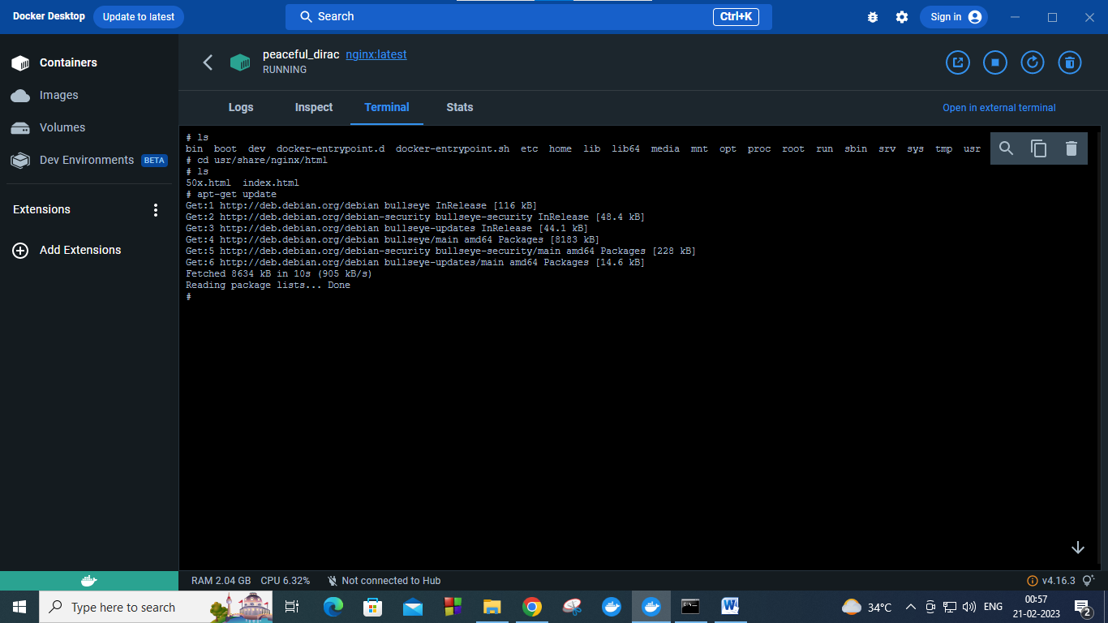

Installing the nano editor in debian base image ie installing nano in container

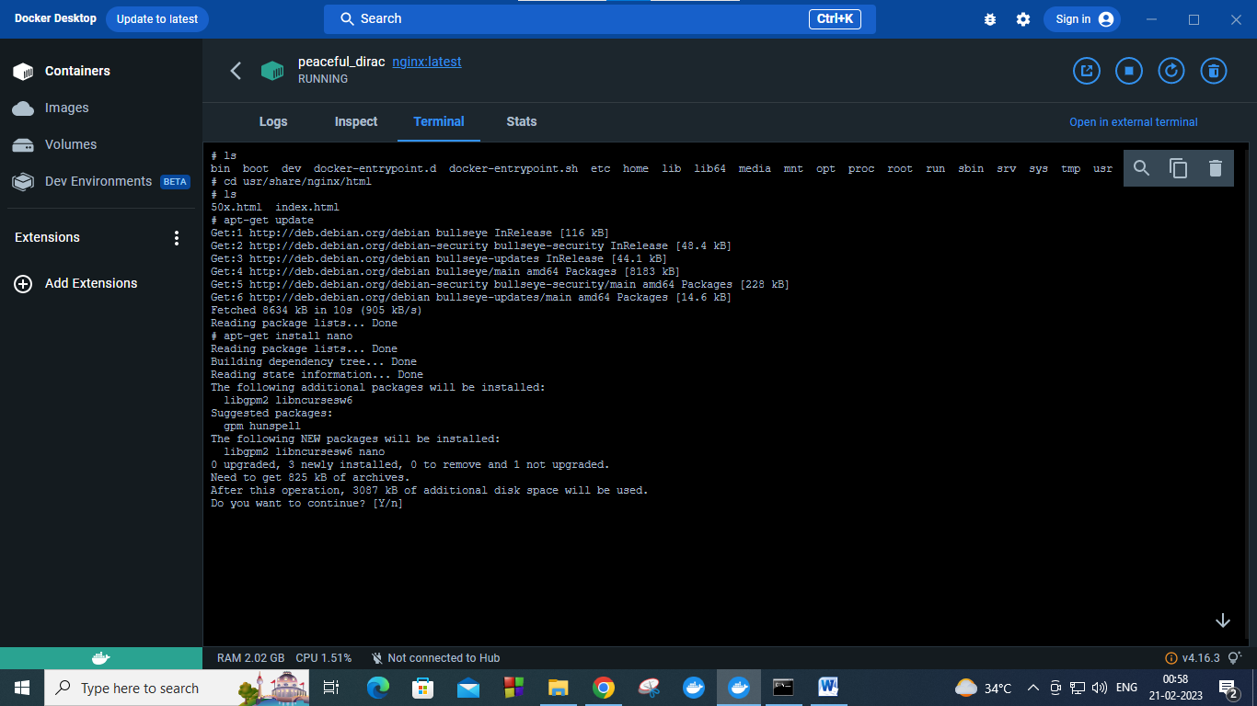

Nano editor installed

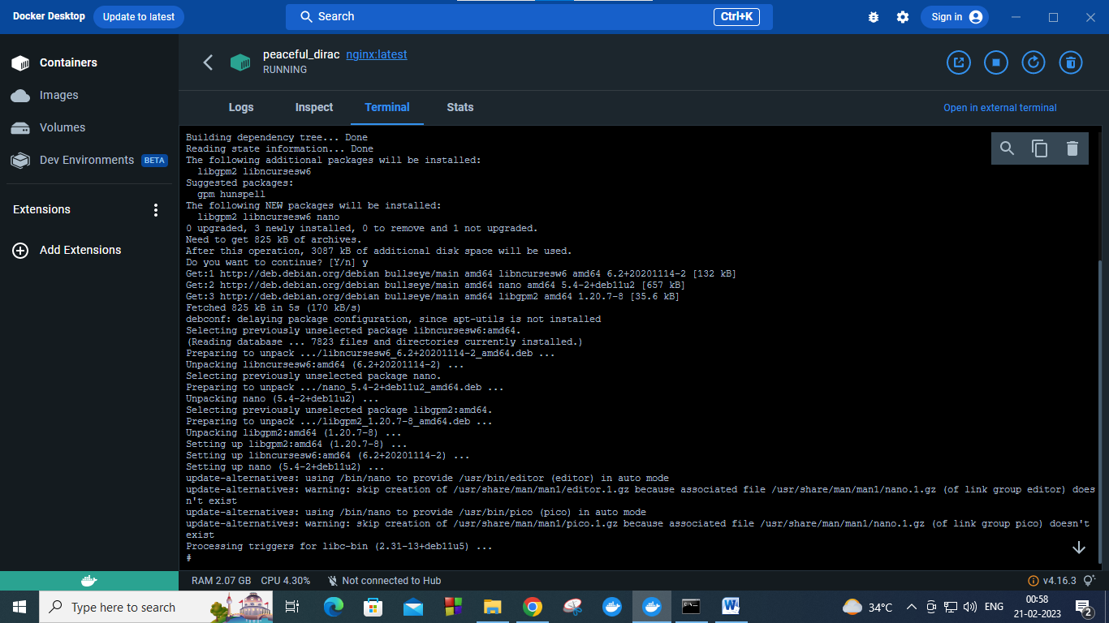

Listing the docker images and tagging the docker image

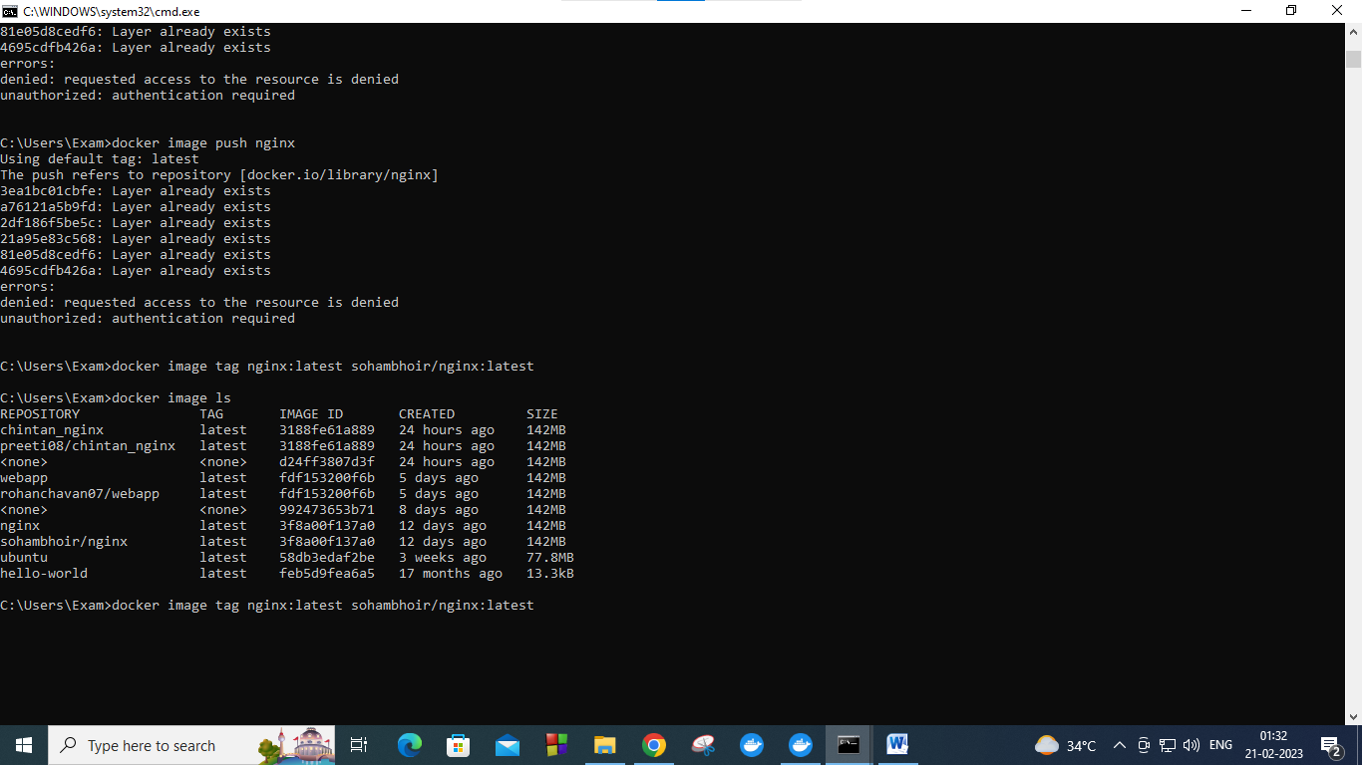

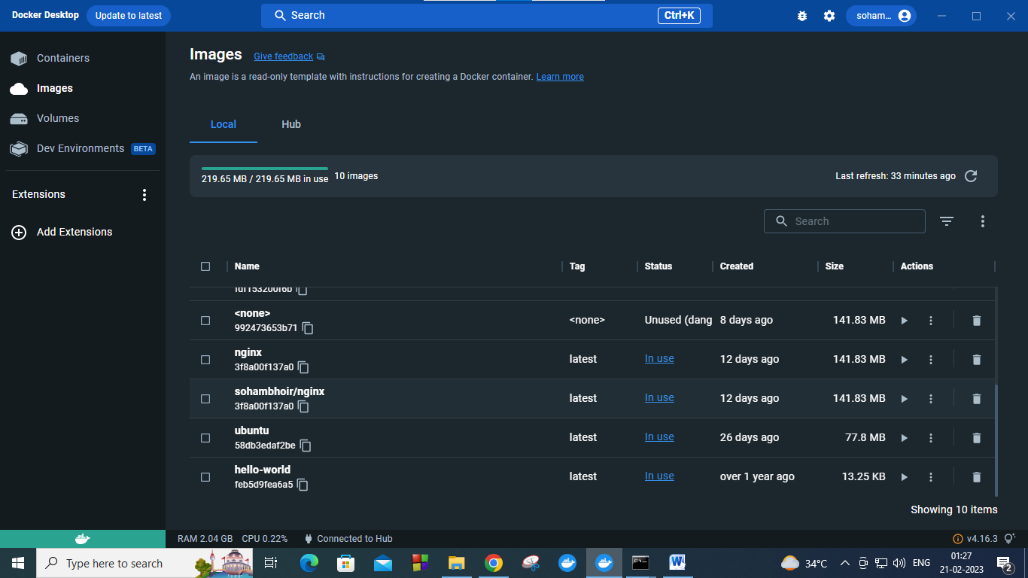

Now pushing the docker image to docker hub from docker desktop image

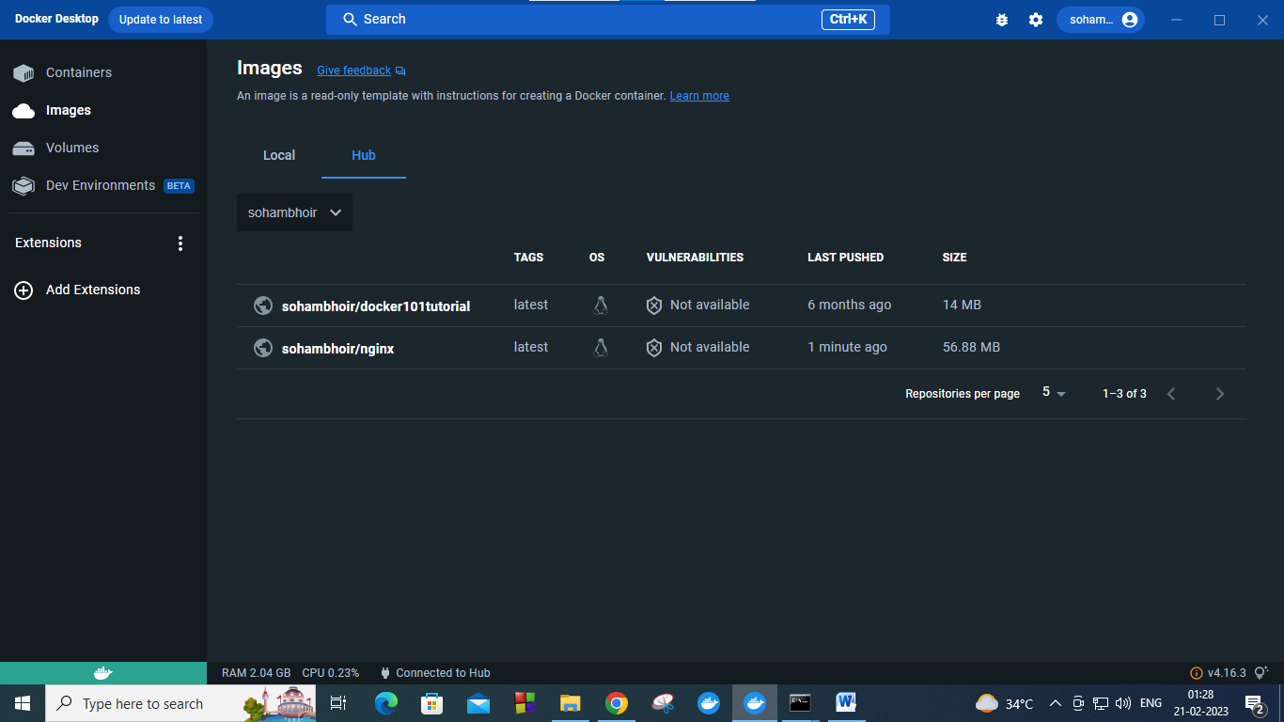

View of docker image as my repository

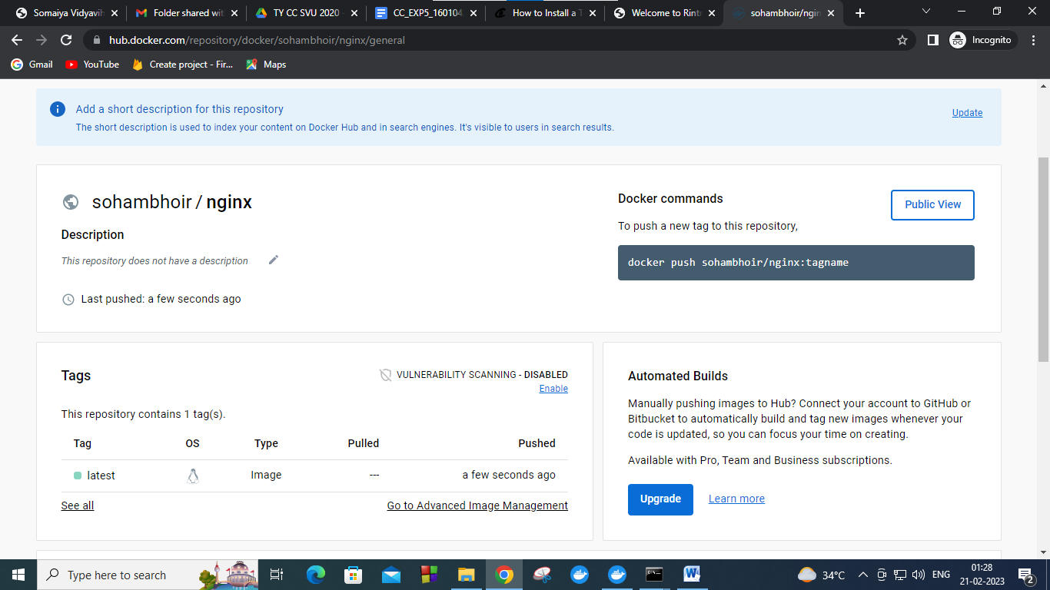

Post Lab Questions:

1. What is Docker file?

Ans) A Docker file is a text file used to build a Docker image, which is a lightweight and portable executable package that contains all the necessary dependencies, libraries, and configuration files to run a specific application or service. The Docker file consists of a series of instructions that tell Docker how to assemble the image by installing the necessary software packages, copying the application code and configuration files, and exposing the necessary ports.

The Dockerfile is typically used in combination with the Docker build command, which reads the instructions in the file and creates a Docker image. This image can then be used to create containers, which are isolated and lightweight runtime environments that can be used to run the application or service. By using Dockerfiles and Docker images, developers can easily package and deploy their applications in a consistent and repeatable way, making it easier to manage dependencies and ensure that the application runs consistently across different environments.